***SPOT* MICRO** Controller*(by Mano Biletsky)*

**WARNING!!:**

**DO NOT CONNECT THE TEENSY’S USB PORT WHILE THE BOARD IS BEING POWERED BY THE “5V INPUT”**

First disconnect external power, then use the USB cable for programming.

**Connections:**

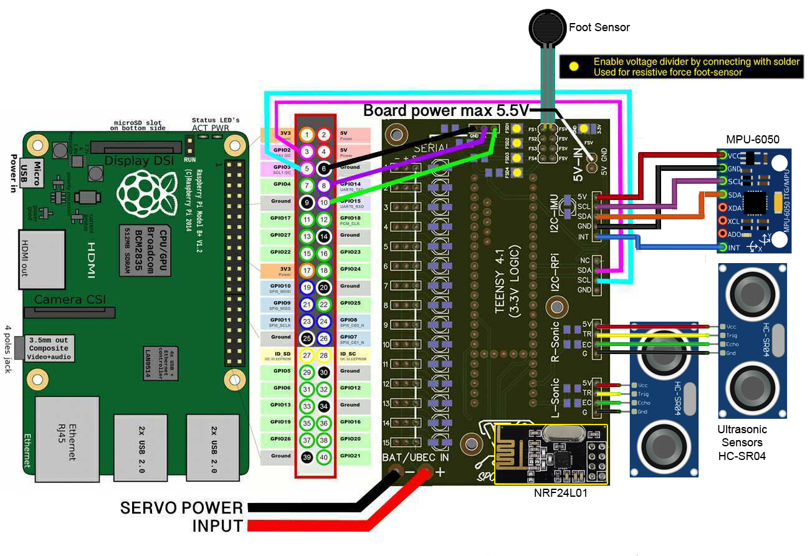

**Todo list:**

√ Radio module integration in main code (remote)

√ I2C connection to Raspberry Pi (sending remote and sensor data to the Pi)

* Ultrasonic sensor integration in main code
* IMU sensor integration in main code
* Add support for servo 13,14 and 15
* Foot sensor to pin 20-23 (instead of A6-A9) (conflicting with I2C)
* Finishing Python receiver code for I2C data + integration in gait code
* Upload code to Github

**Firmware:**

<https://github.com/adham-elarabawy/open-quadruped>

*Adjusted firmware with all added features from the “todo” list soon available here:*

<https://github.com/mano1979/spotmicro>

**Pin declarations:**

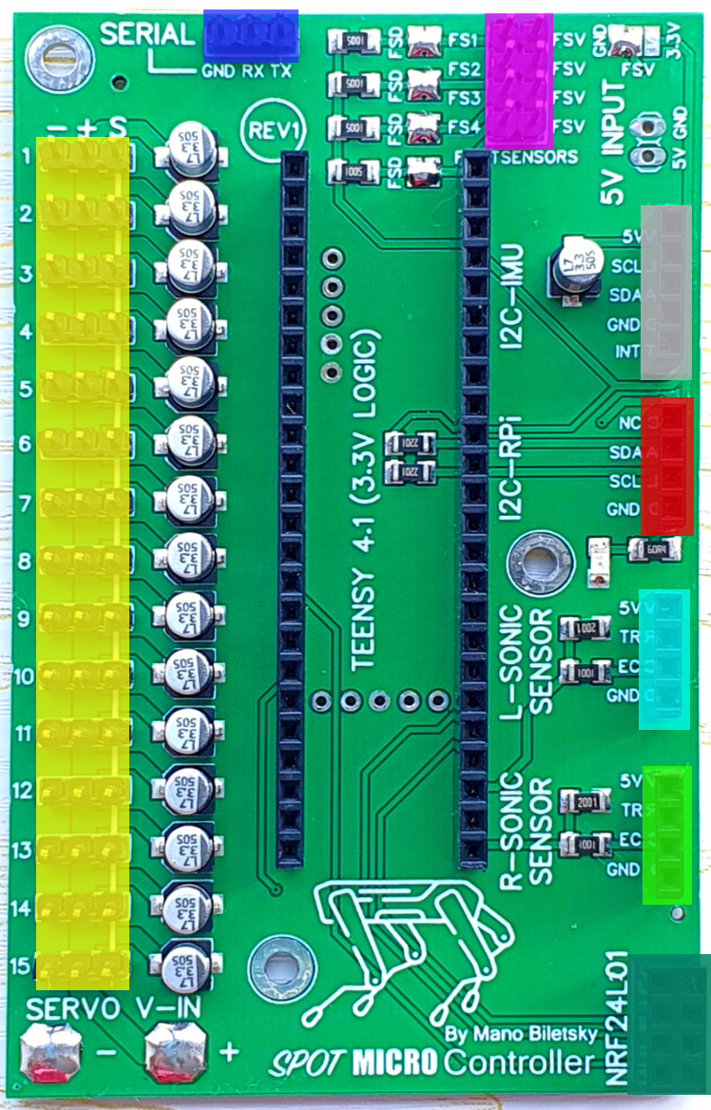Servo Teensy4.1 pin

1 2

2 3

3 4

4 5

5 6

6 7

7 8

8 9

9 10

10 11

11 12

12 13

13 24

14 25

15 28

Right Ultrasonic sensor Teensy4.1 pin

EC 33

TR 34

Left Ultrasonic sensor Teensy4.1 pin

EC 35

TR 36

Foot sensors Teensy4.1 pin

FS1 23

FS2 22

FS3 21

FS4 20

RPI-I2C Teensy4.1 pin

SDA 17

SCL 16

IMU-I2C Teensy4.1 pin

SDA 18

SCL 19

INT 41

Serial (servo control) Teensy4.1 pin

RX 0 (Serial1)

TX 1 (Serial1)

NRF24L01 radio Teensy4.1 pin

CE 37

CSN 38

SCK 27 (SPI1)

MOSI 26 (SPI1)

MISO 39 (SPI1)

IRQ NC

Multi purpose GPIO* Teensy4.1 pin

MPG1 30

MPG2 31

MPG3 32

* Only available on revision 2 and newer